4 - Anchoring pathways
The Anchoring Pathway represents graduates who remain and build their lives in Northeast Minnesota. Their success depends on how strongly high school experiences connect to local postsecondary schools and employment opportunities.

How common is this pathway?
Nearly 30% of individuals that graduated from high school in Northeast are participating in the region’s labor force in a meaningful way five years after graduation (Chart X). Compared to other regions of the state, this is [fill in after doing other reports].

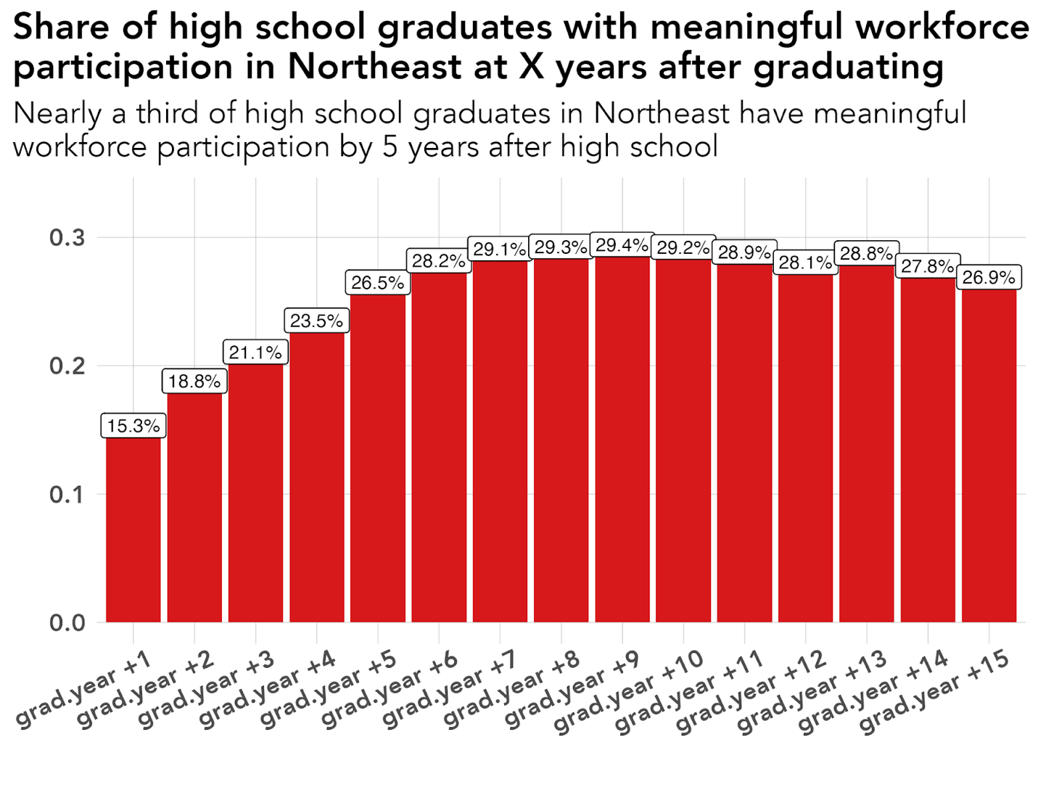
Chart X: 1 in 3 high school graduates in Northeast are participating in the NE labor force in a considerable way. Data: MN Office of Higher Education - SLEDS

Key Characteristics of Anchored pathway

Post-secondary influence
In Northeast Minnesota, 43% of individuals that graduate high school go on to complete college. And, for graduates who continue their education after high school, where they go to college and what kind of credential they earn play a major role in whether they remain connected to Northeast Minnesota’s workforce.
Three key factors stand out: college location, college type, and degree level.

Post-secondary location
Graduation location shows one of the strongest relationships to regional workforce engagement in Northeast Minnesota. Five years after high school, 50.2% of individuals who graduated from a Northeast post-secondary institution were fully engaged in the regional workforce, compared with 18.3% of those who graduated elsewhere in Minnesota and 20.4% of those who graduated outside the state. That’s a 31.9-point advantage over Minnesota graduates outside the region and a 29.8-point advantage over out-of-state graduates. In relative terms, Northeast post-secondary graduates were about 2.7 times more likely than in-state but non-regional graduates—and about 2.5 times more likely than out-of-state graduates—to be fully engaged in the region’s workforce.
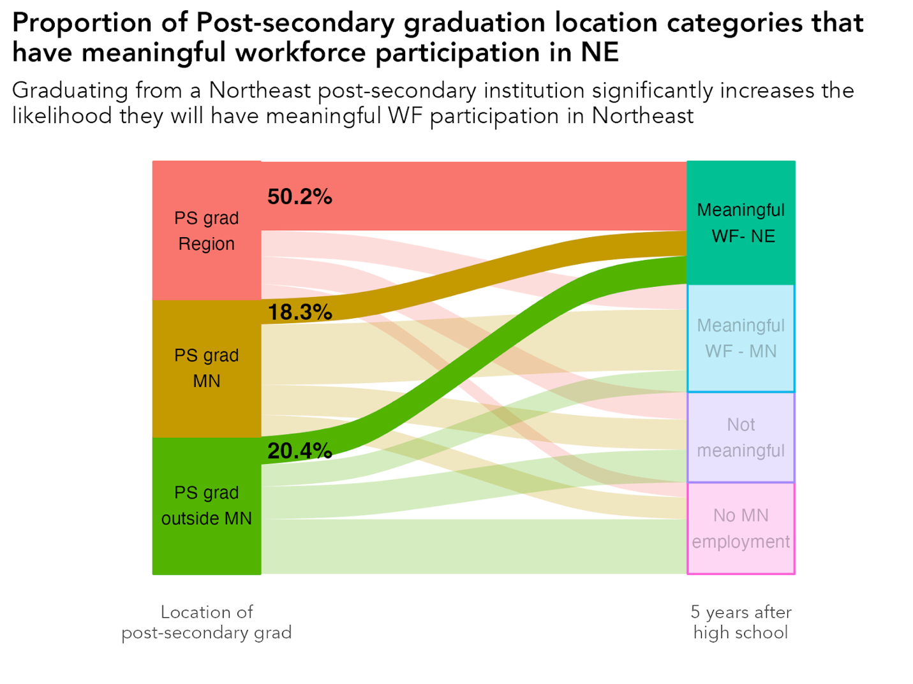
Chart X: Half of Northeast high school graduates who completed a degree in a regional college were participating fully in the Northeast workforce five years after high school. Data - MN Office of Higher Education - SLEDS
This finding underscores the importance of where a student goes for higher education. Students who attend college locally often develop stronger connections with local employers, are exposed to regional job opportunities while studying, and complete internships within the region. These ties frequently translate into permanent employment after graduation.

Degree Type and College Type Also Matter
The connection between education and regional employment is not limited to where students go to college — it is also strongly shaped by what type of institution they attend and what kind of credential they earn. Across both dimensions, the pattern is consistent and striking: two-year colleges and applied credentials are far more likely to lead to meaningful participation in Northeast Minnesota’s workforce.
Roughly half of Northeast high school graduates who earned an associate degree or certificate were meaningfully employed in the region five years after high school. This rate is substantially higher than for graduates who earned a bachelor’s degree or higher, underscoring the strength of applied, workforce-aligned credentials in supporting local employment.
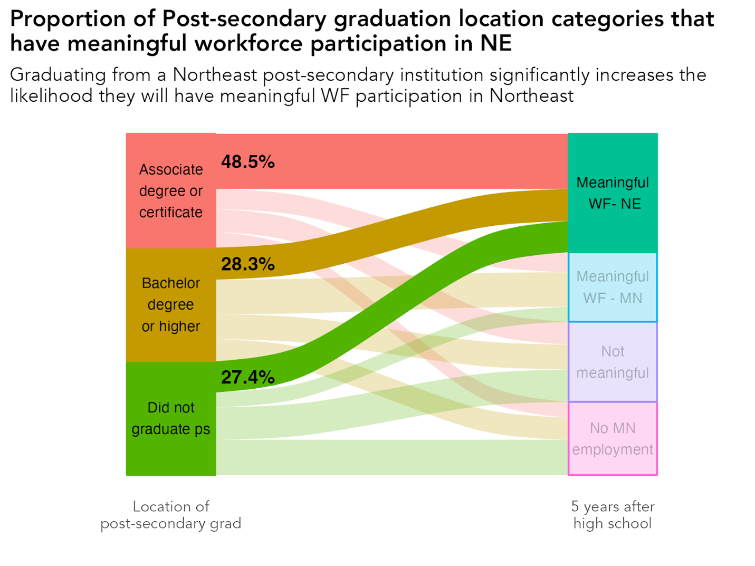
Chart X: A disproportionate percentage of individuals that attain an Associate Degree or certificate are participating in the regional labor force meaningful 5 years after graduating high school. Data: MN Office of Higher Education - SLEDS
The same pattern appears when looking at institution type. Regardless of where the college was located, 50% of graduates from two-year institutions were meaningfully participating in the regional labor force five years after high school. This is more than double the rate observed among graduates who attended only four-year institutions.
Importantly, this regional advantage is not limited to students who exclusively attended two-year colleges. Graduates who attended multiple types of institutions — combining two-year and four-year education — also show strong regional attachment. About 42% of these graduates were meaningfully employed in Northeast Minnesota, compared with just 24% of those who graduated solely from four-year institutions.
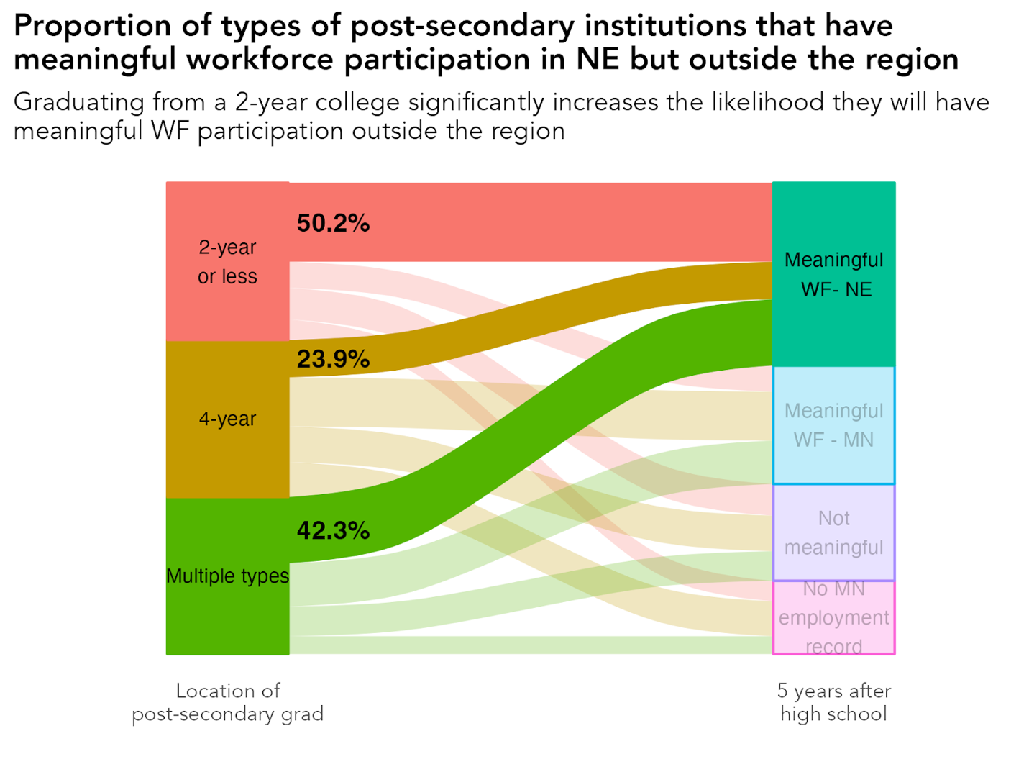
Chart X: Individuals who graduated from a 2-year institution (2-year or less, or multiple types) were twice as likely to be meaningfully participating in the Northeast labor force 5 years after high school compared to graduates of only 4-year institutions. Data: MN Office of Higher Education - SLEDS

Taken together, these findings send a clear message:
Two-year colleges — whether attended alone or in combination with four-year institutions — play a critical anchoring role in the regional labor market.

Encouraging Signs for the Regional Talent Pipeline
The best news for Northeast Minnesota is that a large share of its college graduates already follow these anchoring pathways. Among all high school graduates who went on to complete a college degree:
- 59% graduated from a college located within the region,
- 43% earned an associate degree or lower, and
- 39% graduated from a two-year public institution.
Each of these characteristics—regional college completion, two-year public institutions, and applied degrees—correlates strongly with higher rates of full workforce participation in the region.

Career and Technical Education Influence
The overall most significant finding of our research into pathways for students after high school was discovering the powerful connection between a student’s level of participation in Career and Technical Education (CTE) and gaining full workforce participation in Northeast Minnesota. What’s important about CTE is that it not only had a direct relationship in workforce participation outcomes, but also post-secondary paths that strengthen local workforce participation.
CTE programs are more than individual technical electives. They are, by definition, a “sequence of courses that integrates core academic knowledge with technical and occupational skills, providing students a pathway to postsecondary education and careers.” The key to CTE programs is that they are developed in partnership with regional employers and aligned with local workforce needs. Therefore, participation in CTE connects students to local and regional career opportunities in ways that not only make them aware of the local job opportunities but also let them try the jobs out.

CTE influence on workforce participation outcomes
Students’ engagement in CTE shows a clear and durable relationship with regional workforce outcomes. Five years after high school, 36.7% of CTE concentrators were fully engaged in the Northeast Minnesota workforce, compared with 27.8% of students with no CTE experience—an 8.9-point difference, meaning concentrators were about 32% more likely to be fully engaged. CTE participants also outperformed their peers: 32.6% were fully engaged, an advantage of 4.8 percentage points and a 17% higher likelihood compared to students with no CTE. This stepped pattern—No CTE → Participant → Concentrator—remains consistent at one, five, and ten years after graduation, underscoring that deeper CTE involvement aligns with stronger and more stable workforce attachment in the region.
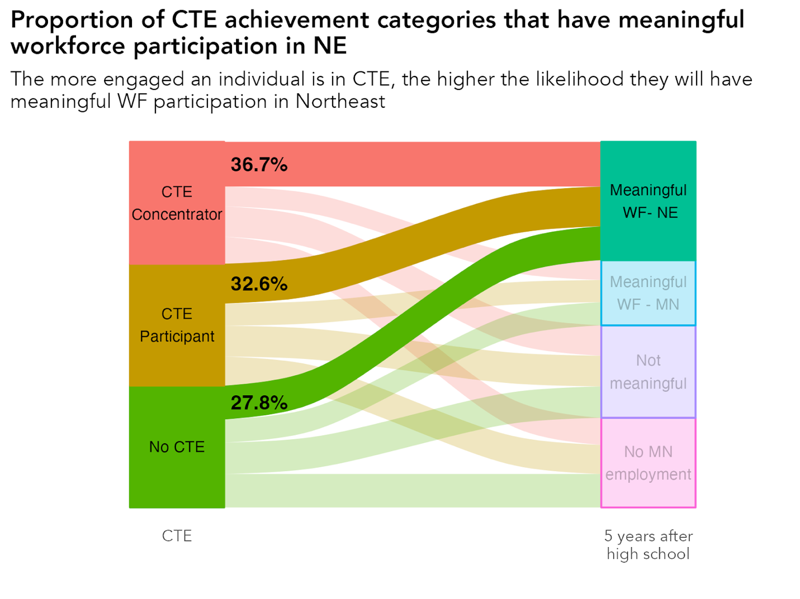
Chart X: As CTE engagement increases so does the likelihood of gaining full workforce participation in the region. Data: MN Office of Higher Education - SLEDS

What makes this relationship particularly important is its persistence. Even when controlling for other factors—such as academic achievement, demographic characteristics, and economic background—CTE participation remained one of the strongest and most consistent predictors of local employment.

CTE influence on higher education pathways
The relationship between career-connected learning in high school and postsecondary choices after graduation is one of the clearest findings in this study. Students who engage in Career and Technical Education (CTE) during high school are not only more likely to stay and work in the region — they are also more likely to choose college pathways that keep them anchored to the region’s workforce.
In short, CTE doesn’t just connect students to work, it connects them to postsecondary pathways that lead back home.
CTE doesn’t just prepare students for immediate employment — it can also shape their educational trajectories. By connecting classroom learning to local industries and regional colleges, CTE builds a bridge between high school and higher education that keeps more graduates rooted in Northeast Minnesota.
Graduates who were CTE concentrators, completers, or even moderate participants showed significantly higher rates of:
- Attending colleges located within the region,
- Enrolling in two-year public institutions, and
- Earning associate degrees or similar credentials—the very pathways most strongly associated with full workforce participation in Northeast Minnesota.
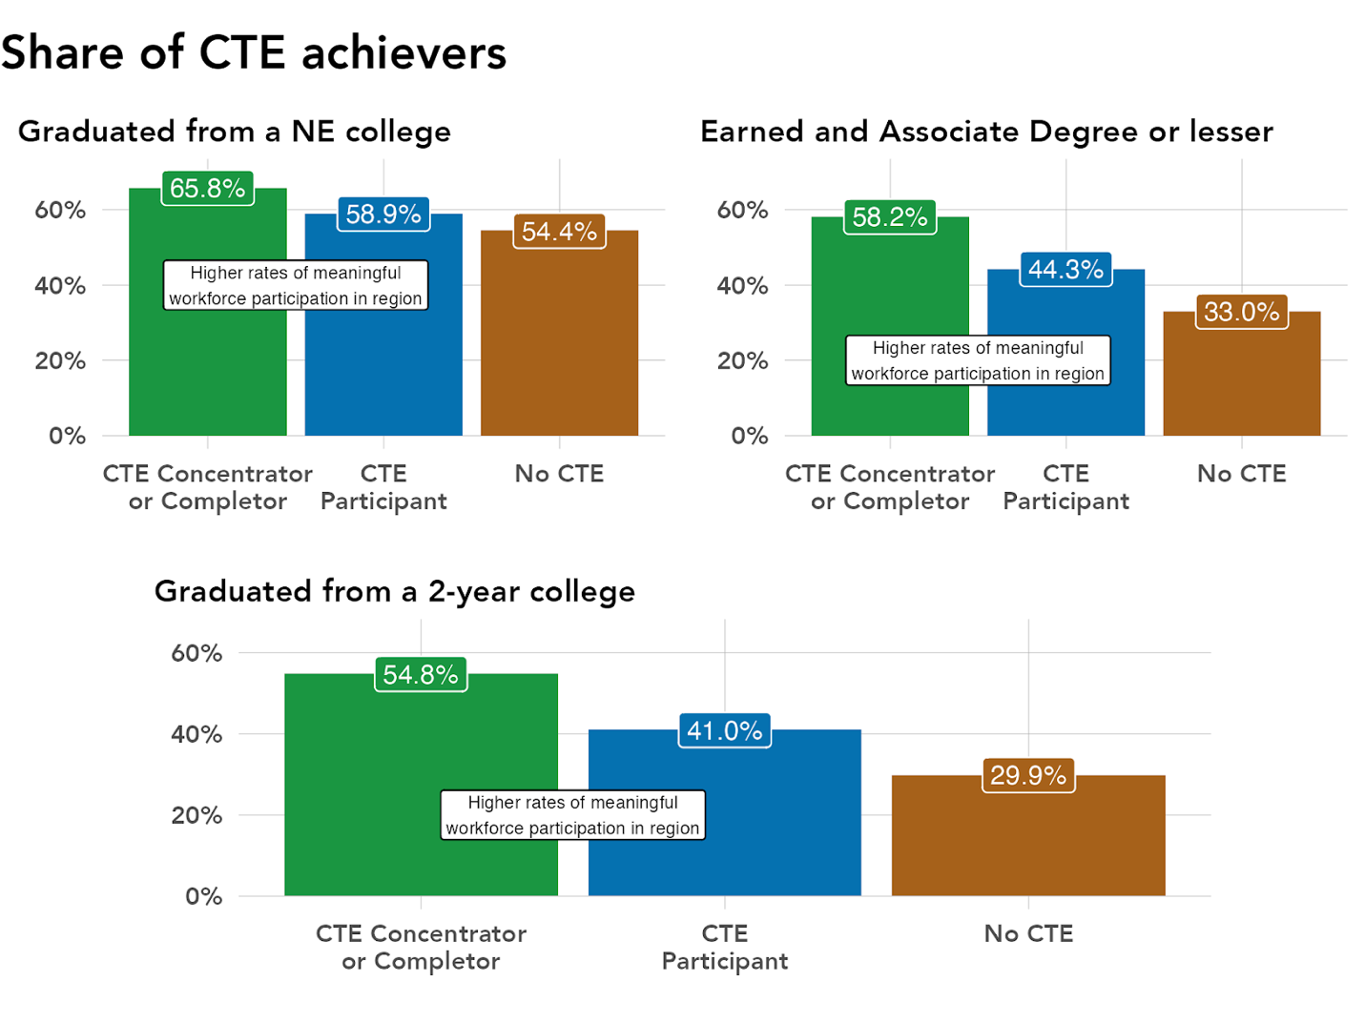
Chart X: Individuals who are more heavily involved with CTE coursework tend to follow post-secondary paths that lead to full workforce participation in the region. Data: MN Office of Higher Education - SLEDS

These relationships reflect how CTE programs are built. Because CTE curricula are developed in collaboration with local employers and regional colleges, students in these programs gain early awareness of career options close to home.
That awareness, coupled with relevant hands-on experience, also makes local higher education the logical next step, not a fallback option.
This alignment between CTE and postsecondary pathways creates what might be called a regional retention loop:
- CTE engagement introduces students to local industries and regional postsecondary programs.
- Students pursue applied education at regional or two-year colleges.
- These institutions prepare them for occupations that exist locally.
- Graduates find full-time work (full workforce participation) in the region’s core industries.

Academic drivers of anchoring
It’s commonly said that higher academic achievers will leave rural areas for college and opportunities in metropolitan areas. However, analysis shows a more nuanced picture where individuals that are more academically prepared can stay in the region to find employment and/or complete college if they are connected to regional career awareness programming.
Our dataset and multiple academic achievement indicators that all pointed in a similar direction - moderate-to-high academic preparation is just as likely to be meaningfully participating in the labor force.

Measuring Academic Preparation
To better understand how high school experiences shape postsecondary and workforce outcomes, this analysis developed a composite measure of academic preparation. Rather than relying on any single test score or program, the measure captures the accumulation of college-oriented academic experiences that consistently emerged across the analysis as being related to postsecondary mobility and workforce outcomes.
The academic preparation score is built from four indicators that reflect both academic performance and engagement with college systems during high school: proficiency on the Minnesota Comprehensive Assessments (MCA) in math, reading, and science; participation in college entrance testing (ACT); performance on the ACT composite score; and participation in Postsecondary Enrollment Options (PSEO). Each indicator was converted into a simple yes/no signal—for example, whether a student reached proficiency on an MCA exam or participated in PSEO—and then summed to produce an overall score. Higher scores reflect greater cumulative exposure to academic experiences designed to prepare students for postsecondary education.
This approach was intentional. Academic preparation is not a single threshold or credential but a continuum of exposure and opportunity. Treating preparation as a cumulative score allows the analysis to examine how outcomes shift gradually as preparation increases, rather than assuming a sharp divide between “prepared” and “not prepared” students.
Importantly, the academic preparation score is not a measure of innate ability or student merit. Instead, it reflects access to and participation in academic opportunities that expand postsecondary options. Exploratory analysis confirmed that these indicators cluster together empirically and are distinct from Career and Technical Education (CTE) participation, reinforcing the interpretation that academic preparation and career-oriented pathways represent separate—but interacting—forces shaping post–high school outcomes.
Within the Anchored pathway, the relationship between academic preparation and regional workforce participation reveals an important nuance. As shown in the chart below, moderate levels of academic preparation are associated with the highest rates of meaningful workforce participation within Northeast Minnesota. Five years after high school, individuals with mid-range preparation scores were most likely to be meaningfully employed in the region. In contrast, those with very low preparation were less likely to achieve stable regional employment, while those with the highest preparation levels were also less likely to remain meaningfully participating in the regional labor force—reflecting the expanded mobility options available to highly prepared students.
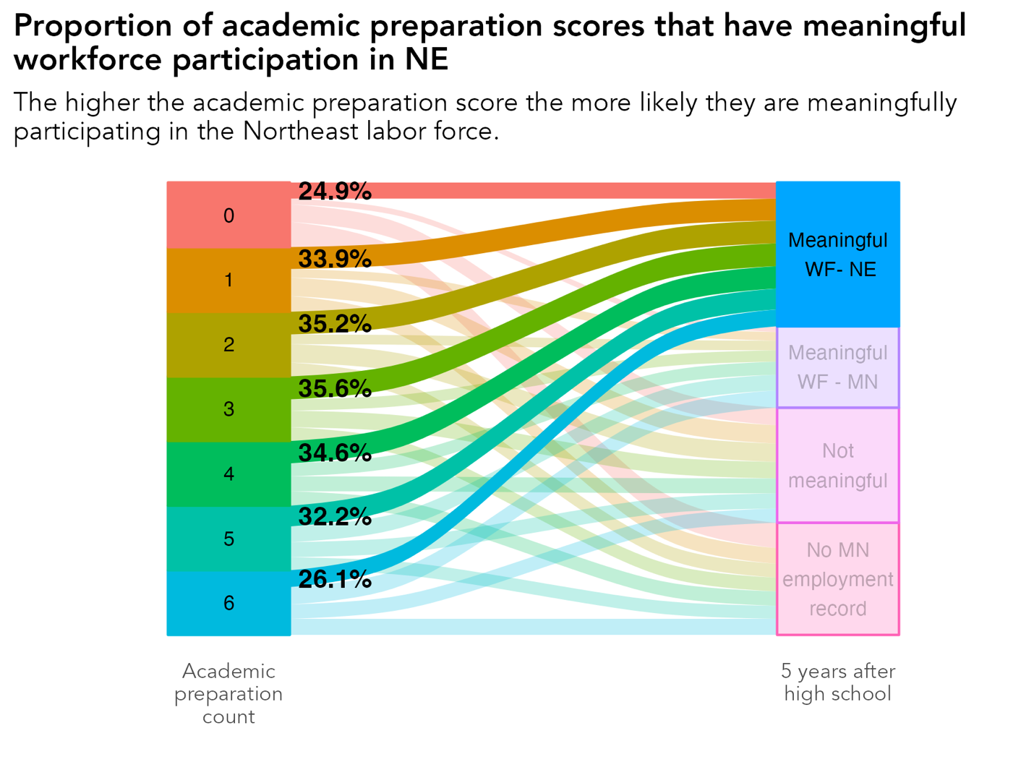
Chart X: The percentage of academic preparation count peaks between scores 2 & 4. Data: MN Office of higher education - SLEDS

Implications for policy and practice
Findings from this study point to three priority considerations:
- Postsecondary completion within the region matters
Completion — not just enrollment — is strongly associated with meaningful local employment. Supporting credential completion at regional institutions is central to strengthening this pathway.
- CTE completion is a key workforce lever
CTE completers are consistently more likely to achieve stable employment in Northeast Minnesota. Expanding access to high-quality CTE pathways can increase long-term workforce attachment.
- Continue to strengthen connection between CTE and local post-secondary institutions
More engagement with CTE programming increased the likelihood of an individual completing college in the region, attaining an Associate degree or similar, and/or completing in a 2-year post-secondary institution - all of which lead to higher likelihood of participating in the regional workforce.

